**VISVESVARAYA TECHNOLOGICAL UNIVERSITY, BELGAUM 590014**



Website DevelopmentReport on

**“Comparative Analysis Of Online Courses”**

By

SHARAN RUDRESH (1BM16CS092)

PRANAV AGARWAL (1BM16CS069)

Under the Guidance of

**Nandhini Vineeth**

Assistant Professor, Department of CSE

BMS College of Engineering

Website Development carried out at



Department of Computer Science and Engineering

BMS College of Engineering

(Autonomous college under VTU)

P.O. Box No.: 1908, Bull Temple Road, Bangalore-560 019

2017-2018

**BMS College of EngineerinG**

**DEPARTMENT OF COMPUTER SCIENCE AND ENGINEERING**



***CERTIFICATE***

This is to certify that the website development titled “Comparative Analysis Of Online Courses” has been carried out by SHARAN RUDRESH (1BM16CS092), PRANAV AGARWAL (1BM16CS069) during the academic year 2017-2018.

Signature of the guide

**Nandhini Vineeth**

Assistant Professor

Department of Computer Science and Engineering

BMS College of Engineering, Bangalore

**BMS College of EngineerinG**

**DEPARTMENT OF COMPUTER SCIENCE AND ENGINEERING**



***DECLARATION***

We, SHARAN RUDRESH (1BM16CS001), PRANAV AGARWAL (1BM16CS002), students of 3rd Semester, B.E, Department of Computer Science and Engineering, BMS College of Engineering, Bangalore, hereby declare that, this website development work entitled "Comparative Analysis Of Online Courses" has been carried out by us under the guidance of Nandhini Vineeth, Assistant Professor, Department of CSE, BMS College of Engineering, Bangalore during the academic semester Aug-Dec 2017

We also declare that to the best of our knowledge and belief, the development reported here is not from part of any other report by any other students.

Signature

SHARAN RUDRESH (1BM16CS001)

PRANAV AGARWAL (1BM16CS002)

1. Introduction

Website development for “Comparative Analysis Of Online Courses”

The website acts as a platform for the user to view details of online courses from multiple websites. The website also keeps track of the users progress in the courses registered on various websites.

The website offers comparative analysis of online courses based on criteria such as duration, effort required, organizations/universities conducting these courses, cost, popularity etc.

**Functionalities**

1. Search for courses by topic and filter them based on duration, difficulty, average rating and cost.
2. Compare selected courses based on various criteria
3. Keep track of their progress in each registered course.
4. The website suggests courses to the user based on their past interests and search queries.
5. Website provides the user with an analysis of their progress.

**Features:**

**Search:**

The user can look for courses using the search option which not only shows the matched queries but also related courses. The searched results can be filtered by duration, difficulty and average rating. The user can choose to view only free or only paid courses. The search results also indicate if the course has been taken by the user.

**Compare:**

Provides the user with detailed comparison of up to three courses. The comparison includes basic information, prerequisites, duration, effort, cost. The website gives a visual comparison of criteria such as average rating, average progress of users, number of enrollments and real life application index. Real life application index is a measure of the usefulness of a course in one’s day to day life.

**User Page:**

The user can update his progress in each course regularly. The user is provided with an analysis of their progress in each course as well as their overall progress in all their registered courses. The user can also rate the courses. The page also suggests courses related to the user’s selected courses.

**2. Webpage Screen shots**

2.1 Login page



Sign Up Page

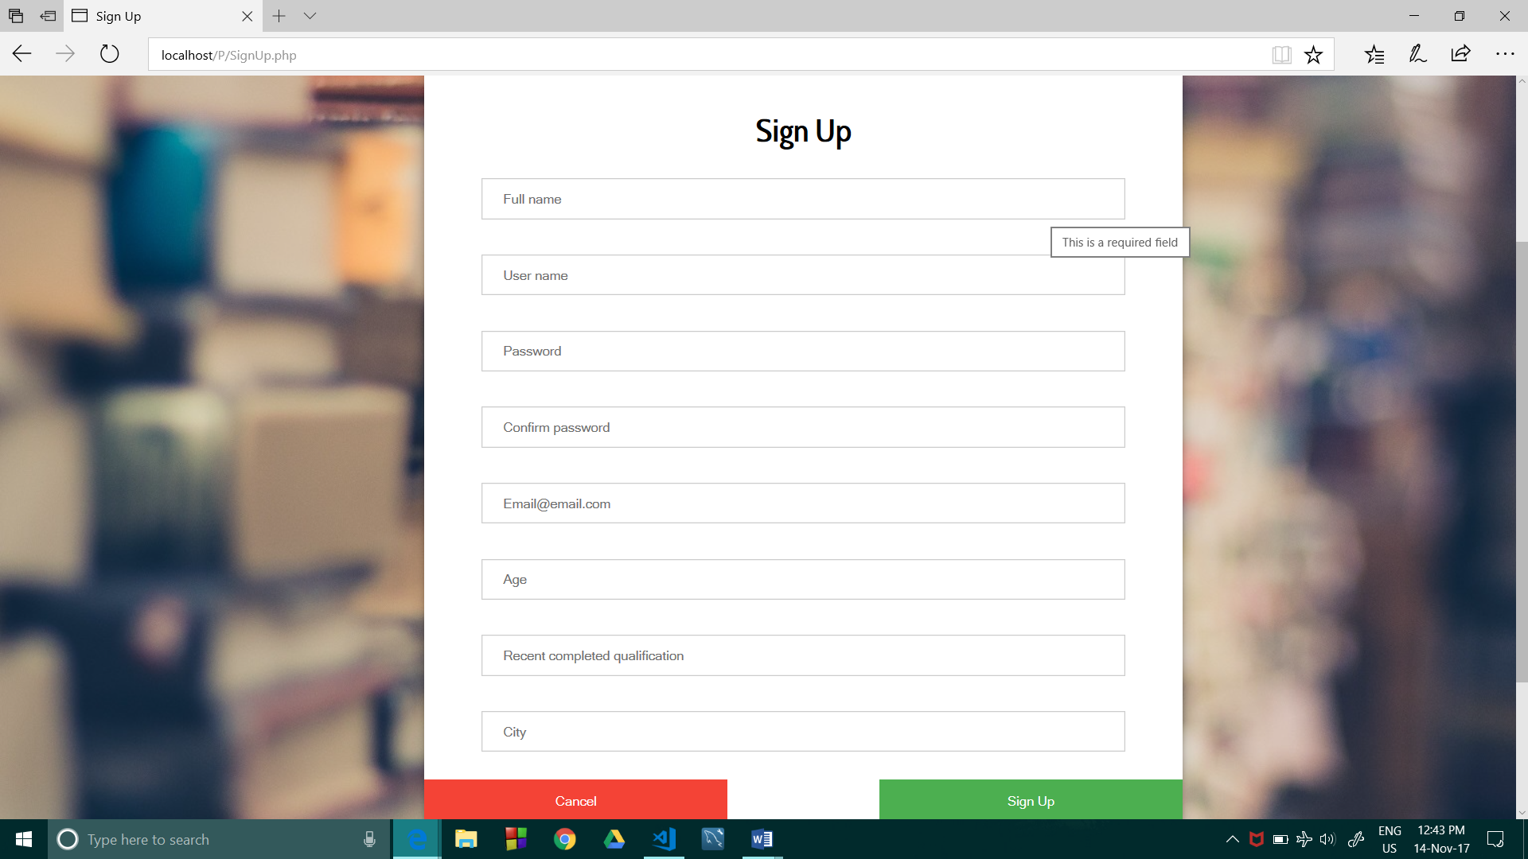

2.2. Home page

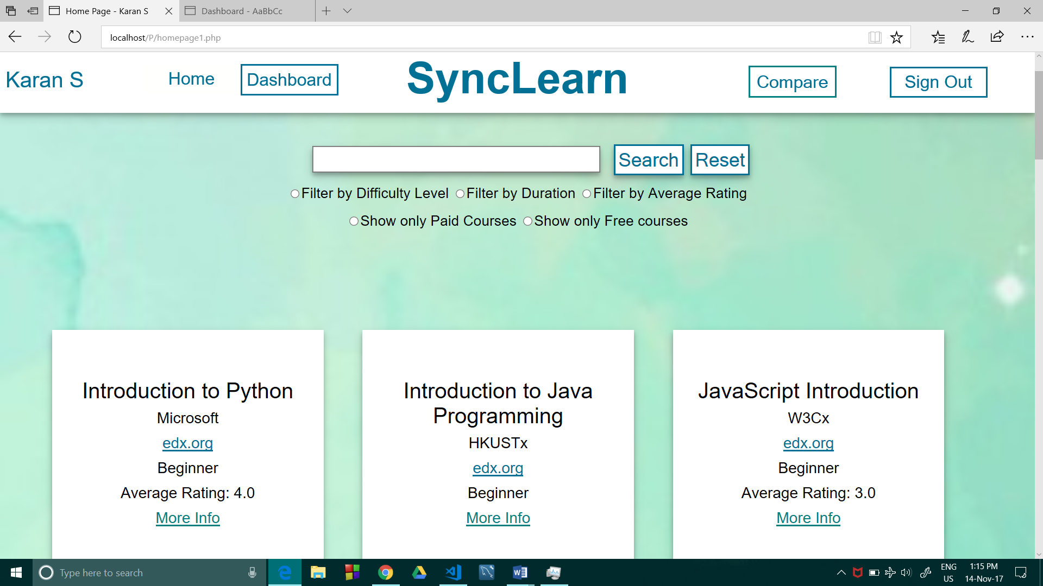

Search: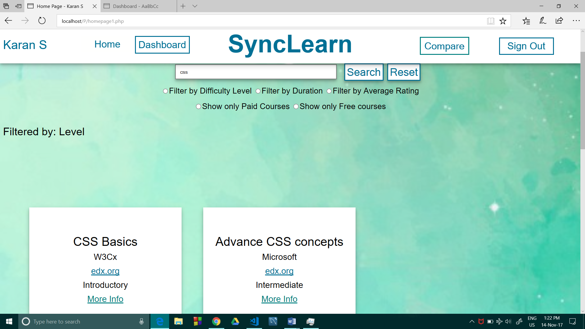

2.3. Dashboard (User Page)

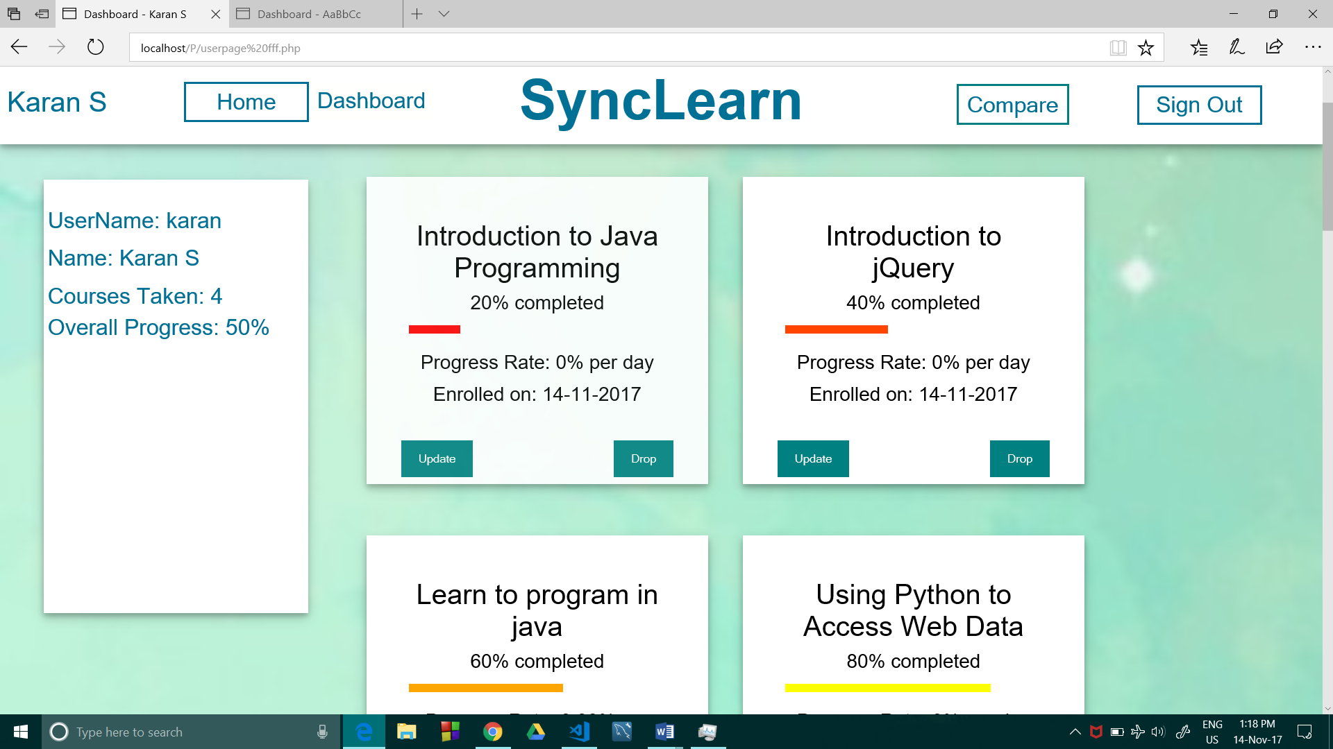

2.4. Comparison Page: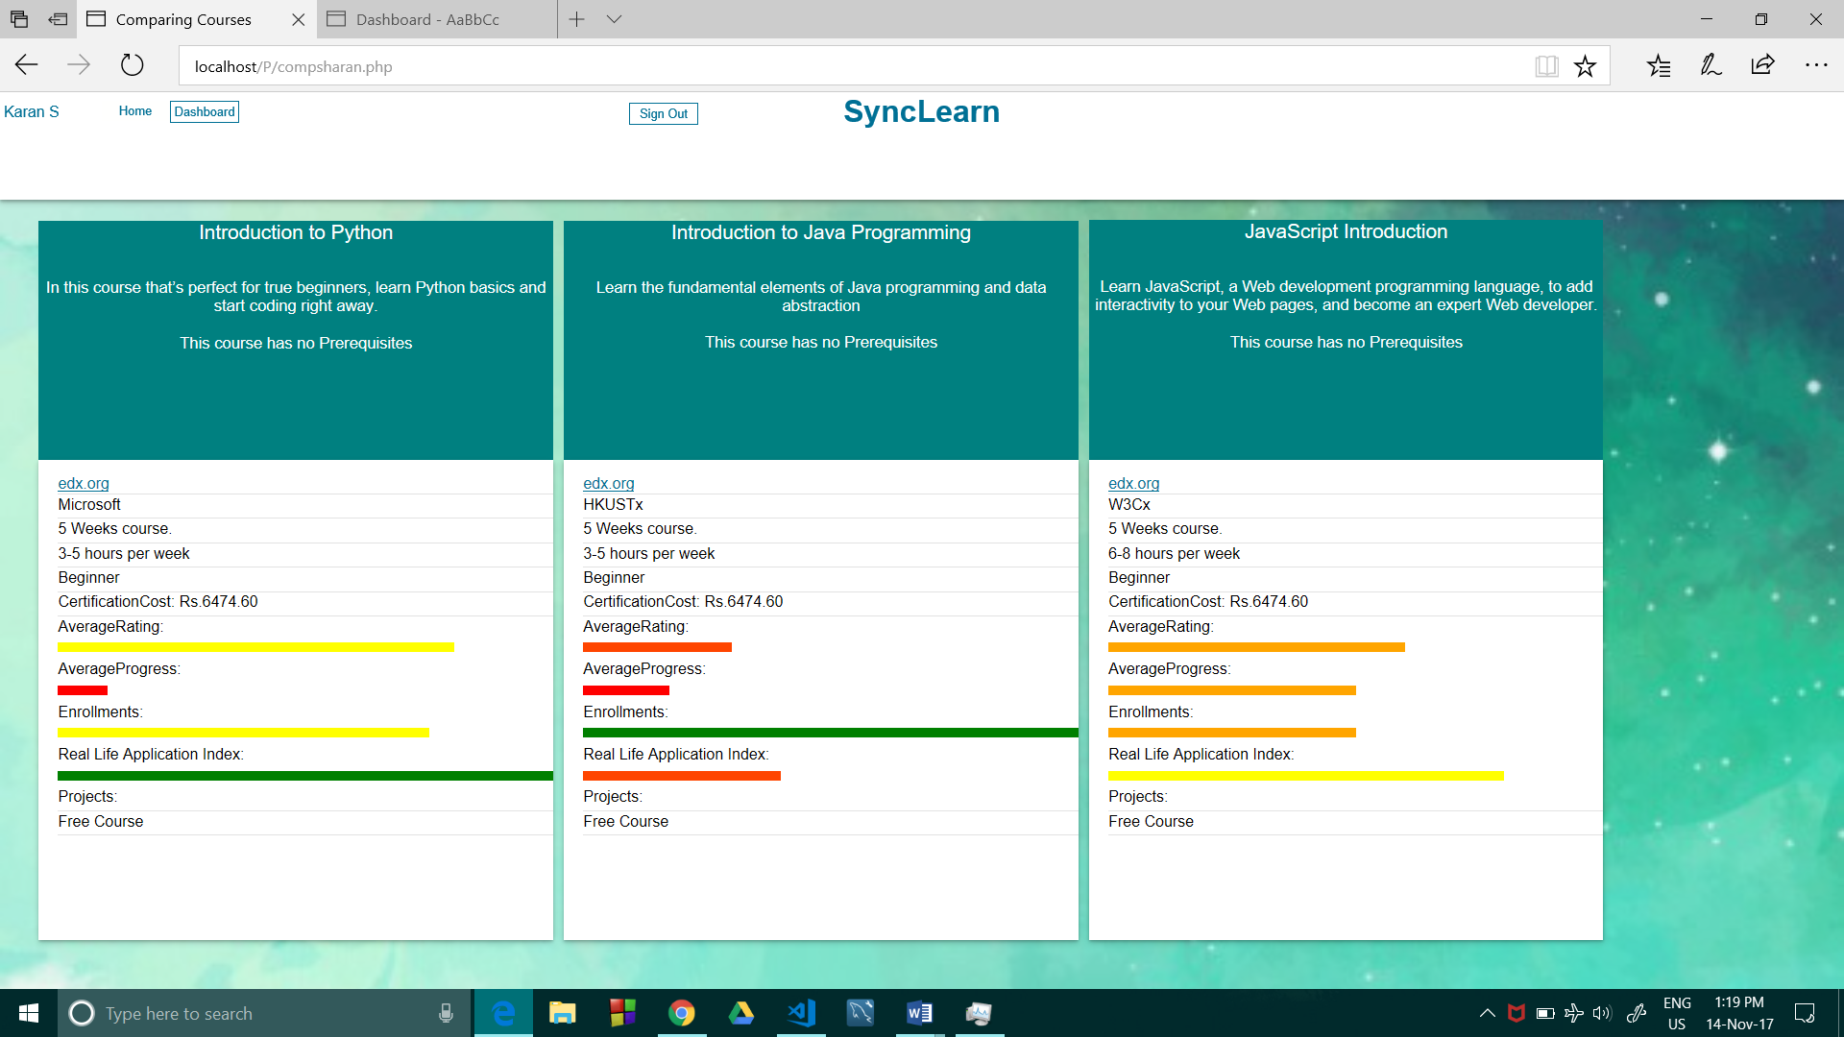

3. Database Table Screen shots

Course Details: Details of the courses

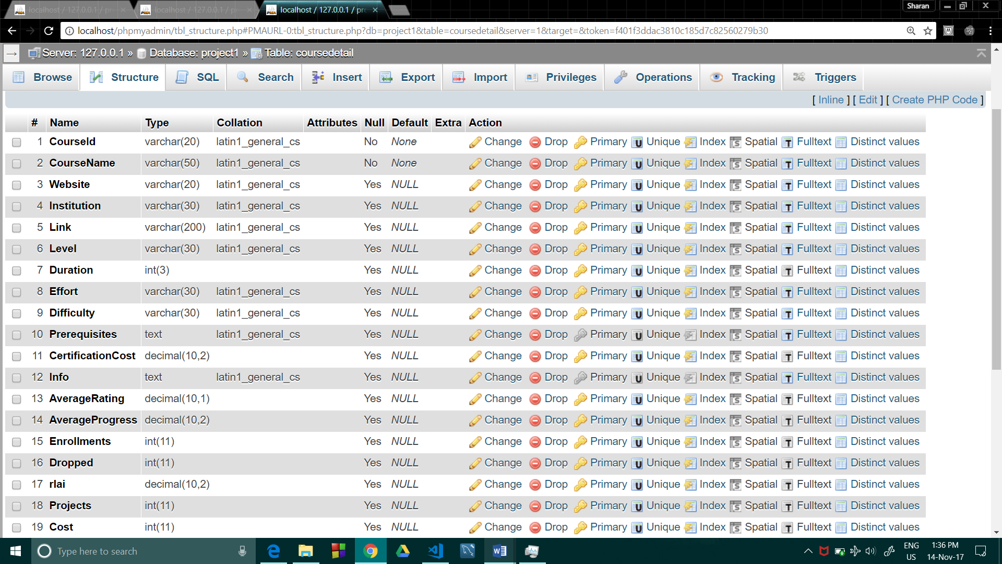

Course Details: Details of the courses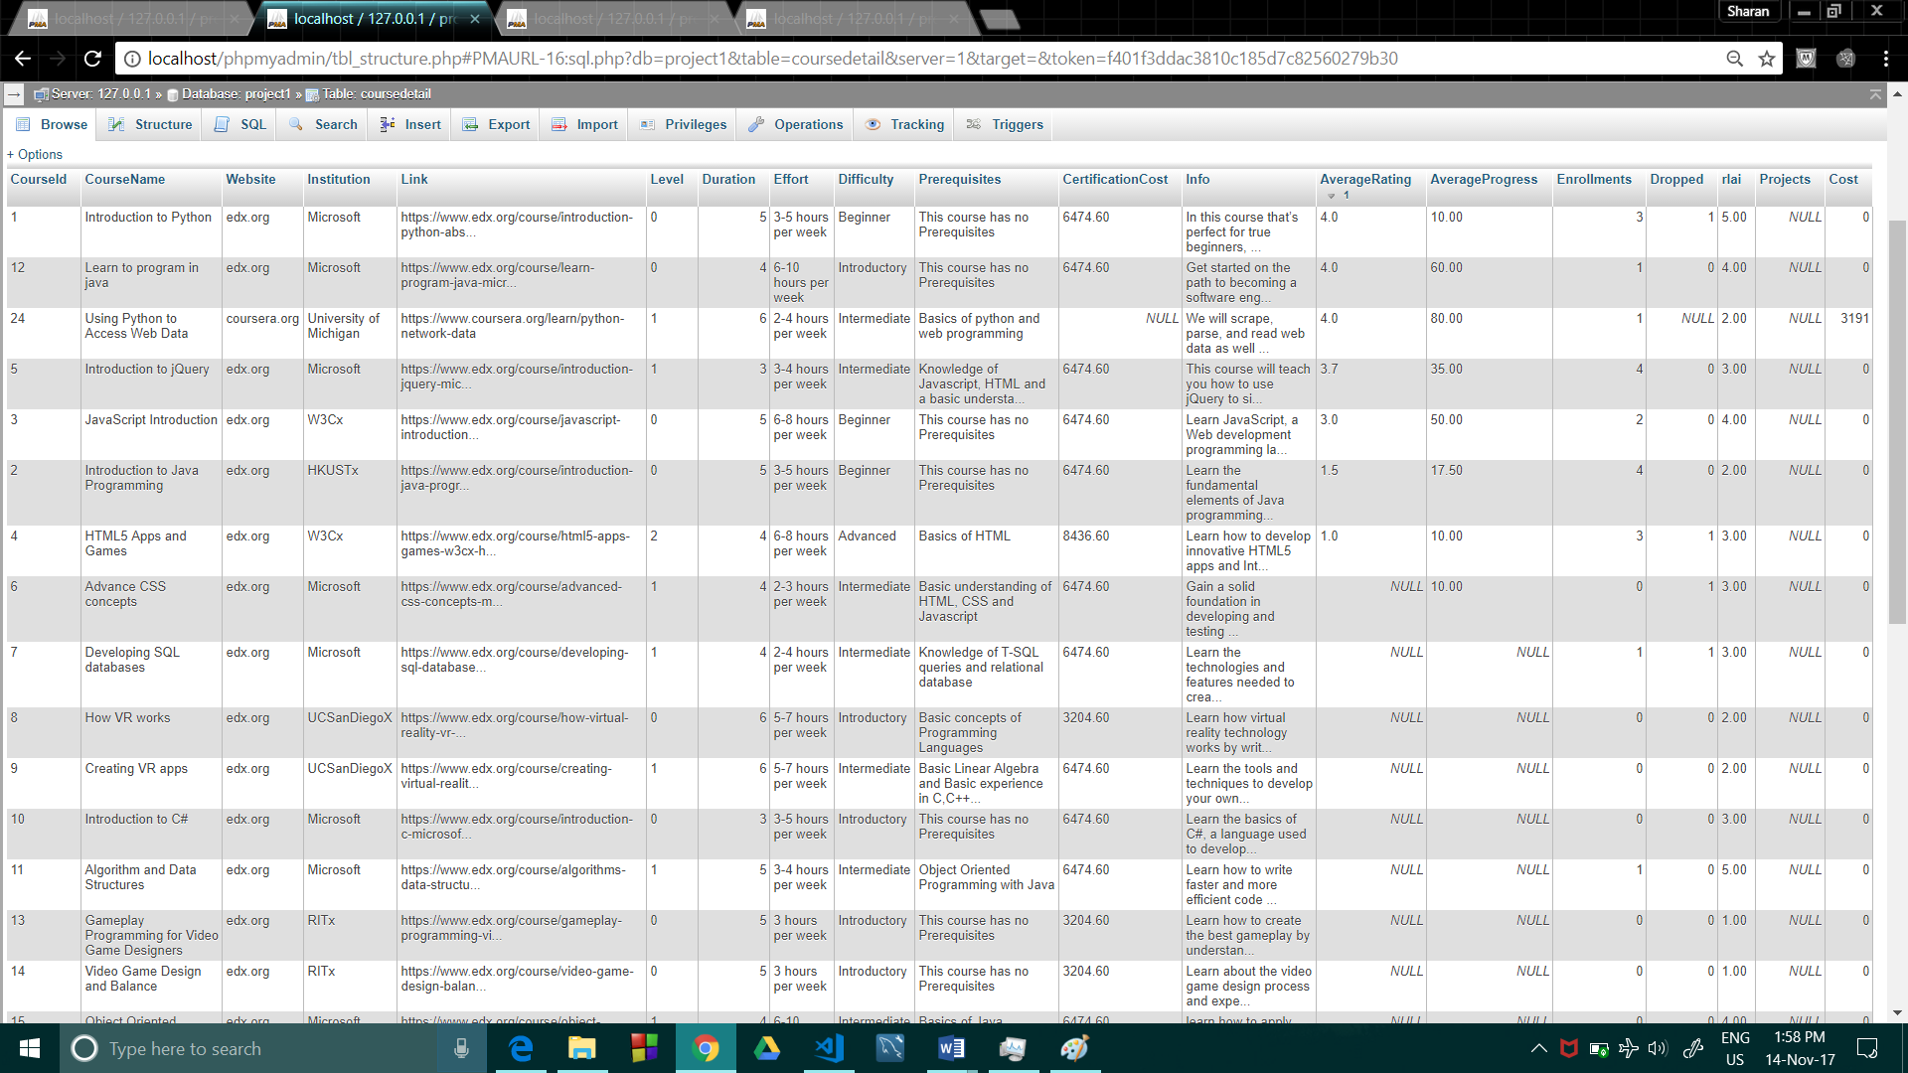

Login User Info Table: contains login credentials

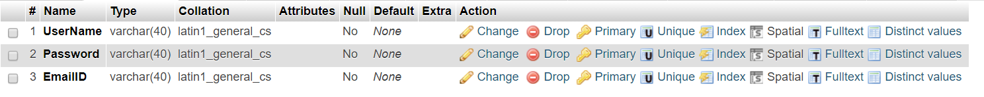

Login Users Database Table: Data

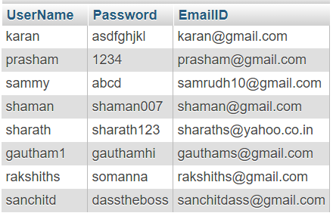

UserProfile : contains the details of the user

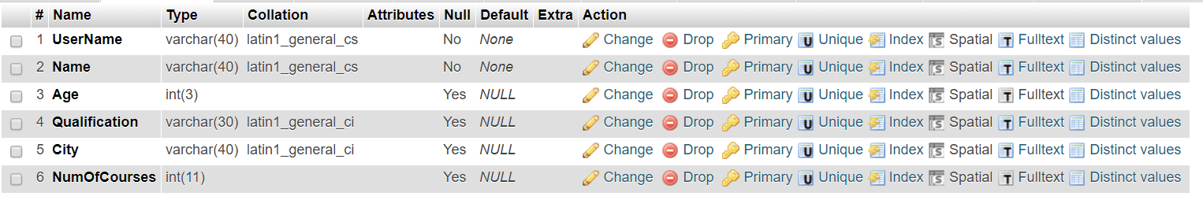

User Profile: Data

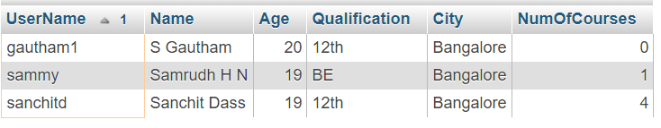

Course Search: Used to search the courses

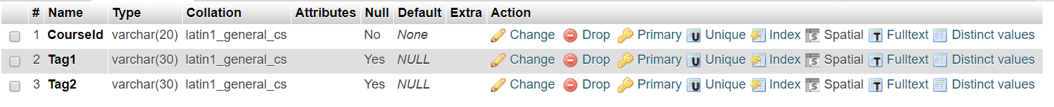

Course Search: Data

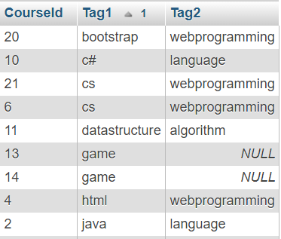

User Courses: Details of the courses taken by the user

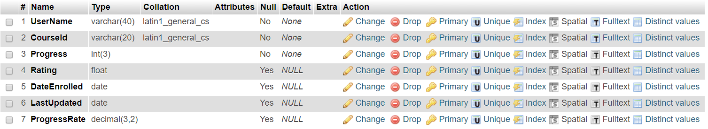

User Courses: Data of courses taken by users

